When running the program for the first time, it will attempt to download the TLE file from celestrak and the ephemeris file for the solar system. **This requires an active internet connection.**

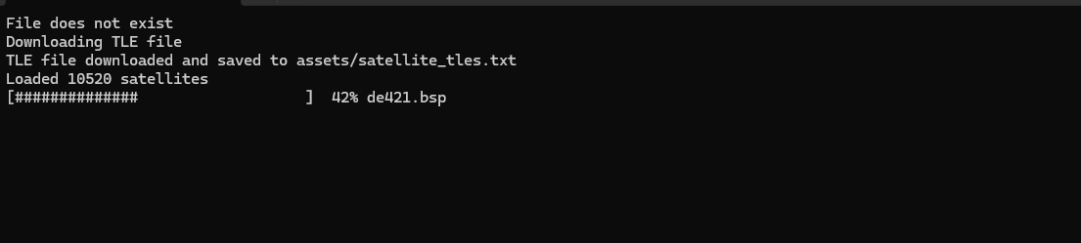

If the loaded satellites number is 0, a bug has occurred

TLEs are valid for 1-2 days. Make sure to Reload TLE before a tracking session. Do not reload more than once per day. **If you spam the reload button norad will block you for 2 hours.**

When TLE and ephemeris are downloaded successfully, or if already existing, the main GUI opens:

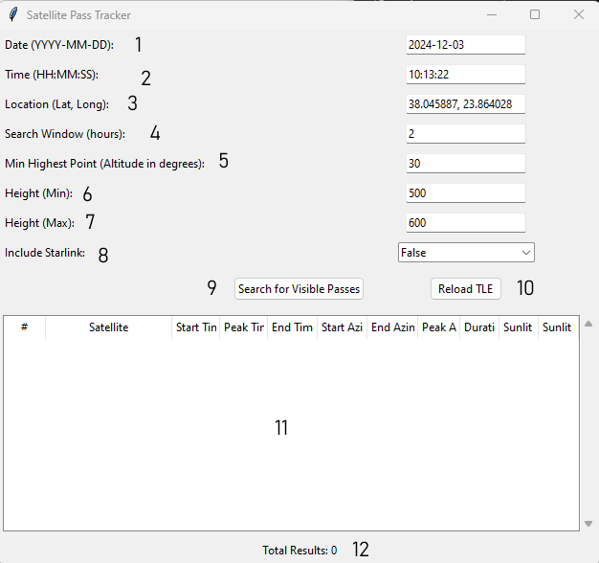

1. Date of the Search window start time (on startup: today)
2. Search window start time (on startup: now)
3. Location of Observer (loaded from config.json)
4. Size of search window (loaded from config.json)
5. Minimum peak elevation of pass (loaded from config.json)
6. Minimum Orbital height (loaded from config.json)
7. Maximum Orbital height (loaded from config.json)
8. Include/Exclude starlink (default: exclude/false)
9. Press to start the search
10. Force download of fresh TLE file.
11. Results display
12. Number of Results

The search algorithm looks for satellites that

1. Are within the set min/max orbital height
2. Overpass the observer location within the defined timeframe (Time + search window)
3. Will be sunlit for at least 30s of that pass
4. Their peak elevation is at least “Min Highest Point”

Set your search criteria and press “Search for visible passes”. Results will populate the results display:

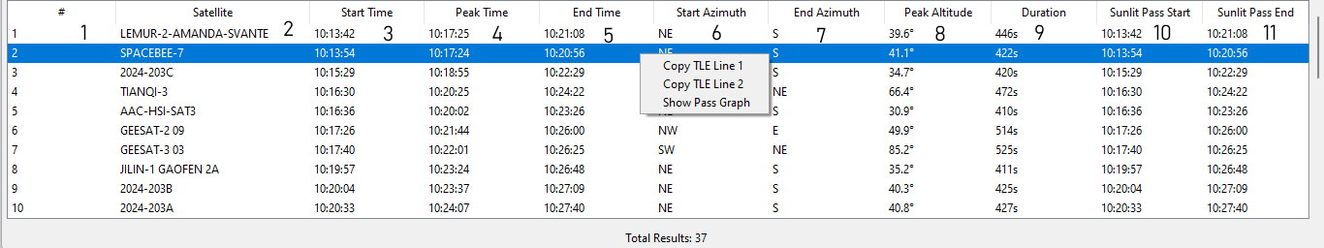

1. Increasing number of result
2. Satellite Name
3. Start time of Pass
4. Time of highest point of pass
5. End time of pass
6. Direction of pass start
7. Direction of pass end
8. Duration of **sunlit portion** of pass
9. Start time of **sunlit portion** of pass
10. End time of **sunlit portion** of pass

Results are sorted by ascending start time. **Passes higher on the list occur sooner.**

Right click on a result to copy its TLE to clipboard or display the Az-El graph for this specific pass:

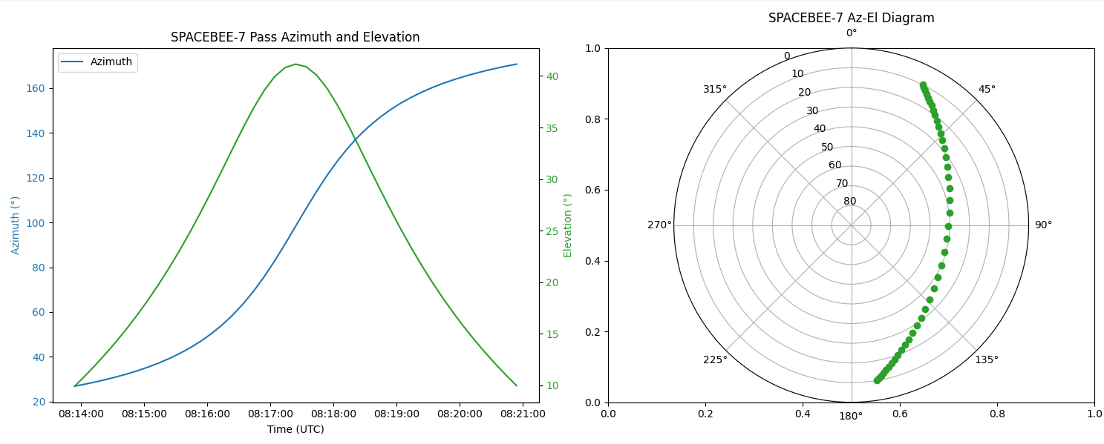

The config.json file can be used to set the default values used on program startup.

The default location has been set to NOA, Penteli

